UNIVERSITY OF ENGINEERING AND TECHNOLOGY PESHAWAR

DEPARTMENT OF COMPUTER SYSTEM ENGINEERING

Digital Image Processing

Assignment no: 1



**Spring 2024**

Submitted by:

**Maaz Habib**

Registration No.: **20pwcse1952**

Section: **c**

Submitted to:

**Dr. Abeer Irfan**

27 MAY 2024

**Implementation of all the intensity transformations (Python/MATLAB)**

Installing library:

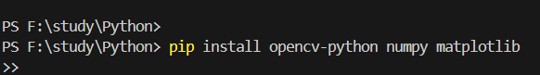

Importing libraries:

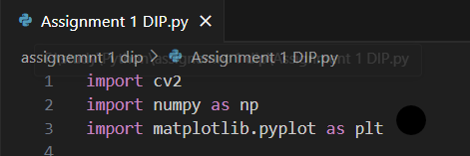

Loading image:

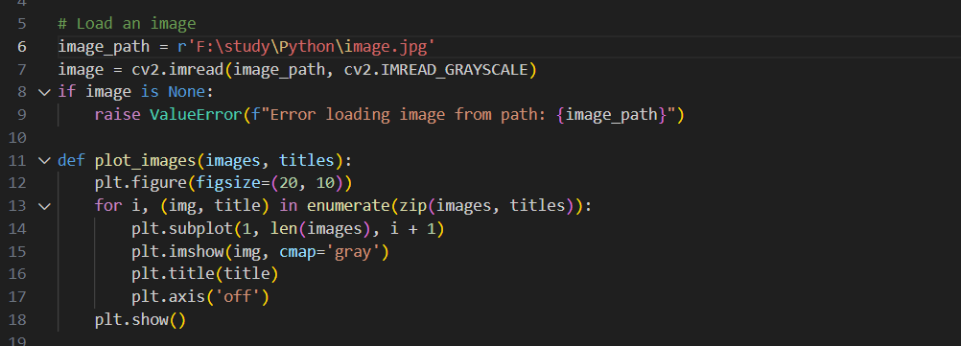

Negative image, Log transformation, Gamma transformation, Apply transformation & Plot Image:

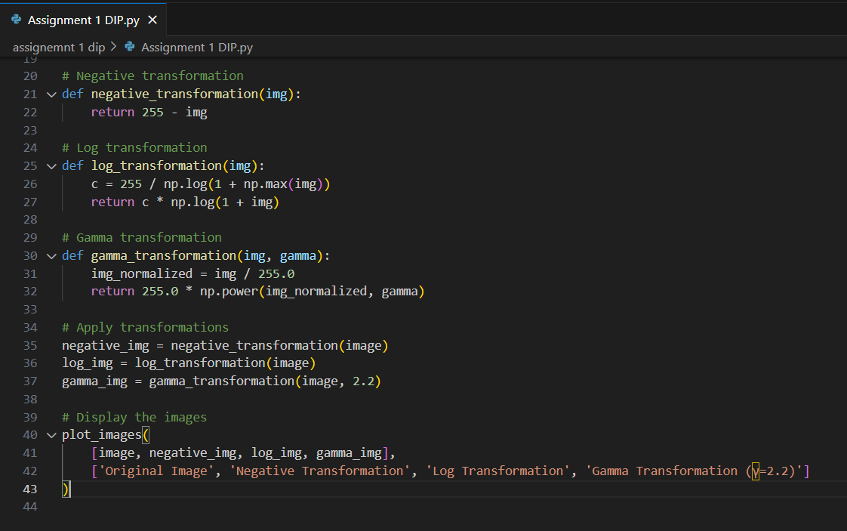

Result: